

Woldia University Student Launch System

***Our group members***

***Name Id Number***

* ***Daniel Tefera ….………………………….1699/08***
* ***Abere Maru ………………………………1640/08***
* ***Yohanes Tiruneh……………………………1924/08***
* ***Rehaset Tesfaye…………………………….1858/08***
* ***Senait Anteneh …………………………….3084/08***
* ***Zewde Ayalew ……………………………..0303/07***

***Content***

*Acknowledgment…………………………………………………………………………………………………..4*

*Introduction………………………………………………………………………………………………………….4*

***CHAPTER 1……………………………………………………………………………………………………………4***

* + 1. *Objective …………………………………………………………………………………………………………4*
    2. *General objective………………………………………………………………………………………….…4*
    3. *Specific objective …………………………………………………………………………………….……..4*
  1. *Purpose of the system …………………………………………………………………………………………5*
  2. *Scope of the system …………………………………………………………………………………………….5*
  3. *Out of the scope ………………………………………………………………………………………………….5*
  4. *Problem of the current system …………………………………………………………………………….6*
  5. *Proposed system ………………………………………………………………………………………………,.6*
  6. *Feasibility analysis ……………………………………………………………………………………………..6*
     1. *Budget …………………………………………………………………………………………………………..6*
     2. *Schedule ………………………………………………………………………………………………………..7*
  7. *System requirement …………………………………………………………………………………………….7*
     1. *Functional requirement ………………………………………………………………………………….7*
     2. *Nonfunctional requirement …………………………………………………………………………….7*
     3. *Hardware and software requirements …………………………………………………………….7*
  8. *Methodology …………………………………………………………………………………………………………7*

***CHAPTER TWO …………………………………………………………………………………………………………8***

*2.1 Conceptual ……………………………………………………………………………….……………………………8*

*2.1.1 Entity identification and description ……………………………………………………………………8*

*2.1.2 Entity and their attributes …………………………………………………………………………………..8*

*2.1.3 Relationship identification and their description …………………………………………………10*

*2.2 logical database design of the project ……………….…………………………………………………..10*

*2.2.1 First narmal form(1NF) ……………………….…………………………………………………………….12*

*2.2.2 Second normal form(2NF) ………….………………………………………………………………………12*

*2.2.3 Third normal form(3NF) …………….………………………………………………………………………12*

***CHAPTER THRE……………………………………………………………………………………………………………14***

*3.1 Physical database design of the project ……………………………………………………………………14*

***CHAPTER FOUR ……………………………………………………………………………………………………….…15***

*4. Implementation and support ……………………………………………………………………………………..15*

*4.1 Data Definition Language (DDL) …………………………………………………….……………………..…15*

*4.2 Data Manipulation Language (DML) …………………………………………………………………….…16*

***CHAPTER SIX …………………………………………………………………………………………………………………24***

*Java implementation ……………………………………………………………………………………………..28*

***Table and figure***

***Table***

*Table 1.1 ………………………………………………………………………………………………………………………………..6*

*Table 1.2 …………………………………………………………………………………………………………………………………7*

*Table 2.1 …………………………………………………………………………………………………………………………………8*

*Table 2.2 …………………………………………………………………………………………………………………………………8*

*Table 2.3 …………………………………………………………………………………………………………………………………9*

*Table 2.4 …………………………………………………………………………………………………………………………………9*

*Table 2.5 ………………………………………………………………………………………………………………………9*

*Table 3.1 …………………………………………………………………………………………………….……………….14*

*Table 3.2 ………………………………………………………………………………………………………………………14*

*Table 3.3 …………………………………………………………………………………………………………………..…14*

*Table 3.4 ………………………………………………………………………………………………………………………15*

*Table 3.5 ………………………………………………………………………………………………………………..……15*

***Acknowledgement***

*First of all we would like to thank my Teacher Instructor Daniel Tefera for his supports and the entire group member for their initiation.*

***Introduction***

*This project is mainly designed for woldia university student launch system.as we know an old information management system is so bored and resource intensive. Most people in the past store data’s in the form of paper and card. This method takes so many things human power, resources, also we can’t retrieve the data fast when we want and other things.so to solve those problems we have to design database.*

***CHAPTER -1***

***1.1 objectives***

***1.1.1 General objective***

*The general objective of this project is to develop a database in titled in woldia university student lounge system.to make it simple and efficient also to facilitate the old process.*

***1.1.2 Specific objective***

* *specific objective of the project is as follows:*
* *Allow the manager to register the customer information especially non cafe student customer.*
* *Allow the manager to register the employee’s information.*
* *Allow the manager to register the product information.*
* *Allow the cashier to calculate the annual income and outcome of the lounge.*
* *Allow the customer and employee to enter data.*
* *Allow the manager to generate reports when wants.*
* *Allow the customer to have simple access and cost saving manner.*
* *Allow the manager to order the supplier.*

* 1. ***purpose of the system***
* *the main purpose of this system is to replace the old manual lounge system by a new database system*
* *To give special works for customer, employees also for the manager.*
* *To decrease the overall resource that is needed by customer, manager and also employees. Like time, money ….*
  1. ***scope of the system***
* *Allow the employee to enter data.*
* *Allow the manager to generate reports.*
* *Allow the customer to record data’s what they eat per day especially for non-cafe students.*
* *Control unnecessary deletion of data.*
* *The system support user account management.*
* *The system prevent from unnecessary deletion of data from the system.*
* *The user can search from the system by their unique primary key.*
  1. ***out of the scope***
* *This system doesn’t allow the user or the customer to make order at distant area because the system doesn’t have network programing.*
* *This system doesn’t allow the manager to pay his annual tax online.*
* *This system does not allow the employee to receive their salary online.*
* *This system does not allow the manager to order the supplier to get his raw materials in online.*
* *It takes time to train the user of this system because this is unfamiliar for the user that who is illiterate people.*
* *The user cannot change the password of another account*
  1. ***problems of the current system***
* *The systems do not allow to access for illiterate employee, customer and manager.*
* *Also difficult to use for beginners.*
* *Difficult for troubleshooting when problem is occur.*
* *Difficult to trouble shoot when the error is occurred simply it needs the skilled person to trouble shoot.*
* *Difficulties to cross check, to order, the availability of the product in the system.*
  1. ***proposed system***

*The new woldia university student launch system make the process efficient, accurate and user friendly generally solve the problem of the existing system by:*

* *Automating the system(WDULaunch system)*
* *Providing easy communication between customer and employee also between employee and supplier.*
* *Generating reports for the authorized user when needed.*
  1. ***Feasibility analysis***
     1. ***Budget***

*For the woldia university student launch management system we spend the following materials and their costs*

|  |  |  |  |
| --- | --- | --- | --- |
| *Number* | *Description* | *price* | *Total* |
| *1* | *Desktop computer* | *10,000* | *10,000* |
| *2* | *HP Laptop computer* | *12,000* | *12,000* |
| *3* | *MySQL server* | *100* | *100* |
| *4* |  |  |  |
| *5* |  |  |  |
|  | *Total* |  | *22,100* |

*Table 1.1*

* + 1. ***Schedule***

|  |  |  |
| --- | --- | --- |
| ***Project phase*** | ***Project start date*** | ***Project end date*** |
| *Phase 1: Project initiation* | *March 1,2009* | *March 5,2009* |
| *Phase 2: Conceptual and logical database design* | *March 5,2009* | *March 26,2009* |
| *Phase 3: Physical database design/implementation* | *April 1,2009* | *April 10,2009* |
| *Phase 4: Application develop and demonstration* | *April 15,2009* | *April 28,2009* |
| *Phase 5: Peer to peer review* | *Jun 9,2009* | *May 10,2009* |
| *Project submission date* | | *Jun 10,2009* |

*Table 1.2*

* 1. ***System requirement***
     1. ***functional requirement***
* *The system allow cashier to generate report*
* *The system allow the manager to enter username and password*
  + 1. ***Hardware and software requirements***
* ***Hardware requirement***
* *Pc, Pentium 4, 4GB RAM, 2.0 GHZ and above, 400 GB Hard Disk and above.*
* ***Software Requirements***
* *Windows 8 and above*
* *SQL 2005*
* *Anti-virus like smadave ,Avast*
  1. ***methodology***

*The methodology that we use for this project is:*

* *Observation*
* *Interview*

***CHAPTER 2***

1. ***Database design***

***2.1 conceptual designs***

***2.1.1 Entity identification and their description***

*Woldia university student launch management systems have the following entities.*

1. *Employee: employee is the major actors for this system they have different characteristics (attributes).*
2. *Customer: customer has a vital role in this system also it have different characteristics (attributes).*
3. *Order: is another important entity in the system also it have different characteristics (attributes).*
4. *Supplier: is another important entity in the system that supplies raw materials and soft drinks to the launch.*
5. *Food: the major important entity in the system that is supplied to the customer is food and it has different type and characteristics (attributes).*

***2.1.2 Entity and their attributes***

*For the above entity they do have the following attributes:*

|  |  |
| --- | --- |
| *Entity* | *Corresponding attributed* |
| *Customer* | *FName* |
| *LName* |
| *Sex* |
| *Cust Age* |
| *P code* |
| *Cust ID* |
| *Cust tel* |
| *Cust city* |

*Table 2.1*

|  |  |
| --- | --- |
| *Entity* | *Corresponding attributes* |
| *Order* | *Order date* |
| *Payment type* |
| *Paid date* |
| *Order quality* |
| *Order quantity* |
|  |

*Table 2.2*

|  |  |
| --- | --- |
| *Entity* | *Corresponding attributes* |
| *Food* | *Food name* |
| *Food number* |
| *Quantity* |
| *Price* |
| *Product code* |
| *Soft drink* |
| *Hot drink* |
| *Breakfast* |
| *Dinner* |
| *Lunch* |

*Table 2.3*

|  |  |
| --- | --- |
| *Entity* | *Corresponding attributes* |
| *Employee* | *FName* |
| *LName* |
| *Emp ID* |
| *Salary* |
| *Emp position* |
| *Emp tel* |
| *BOD* |
| *Sex* |
| *Hire Date* |
| *Experience* |
| *Quallification* |
| *Emp City* |
| *Emp age* |
|  |

*Table 2.4*

|  |  |
| --- | --- |
| *Entity* | *Corresponding attributes* |
| *Supplier* | *Sup tel* |
| *Sup city* |
| *Supplier name* |
| *Supplier city* |
| *Supplier no* |

*Table 2.5*

***2.1.3 Relationship identification and their description***

* *Relationship that we use in the system is listed below with their identification.*

1. *Supplied for:-This relationship is between Customer and Food.it has one to many relationship.*
2. *Make: -This relationship is between Customer and Order.it has one to many relationship one order can be made by only one Customer but one Customer can make many Order.*
3. *Receive:-This relationship is between Employee and Order. An employee receives an order. It has one to many relationship one order can be received by only one employee but employee can receive many orders.*
4. *Prepared for:-This relationship is Food and Customer. It has many to many relationship with many food can be prepared for many customer.*
5. *Receive order from:-This relationship is between Supplier and Employee. It has many to many relationships.*

***CHAPTER 3***

***Physical database design of the project***

***Data dictionary***

|  |  |  |  |  |
| --- | --- | --- | --- | --- |
| ***Customer*** | | | | |
| ***Column*** | ***Data definition*** | ***Data type*** | ***Length*** | ***Allow null*** |
| *FName* | *Customer First Name* | *Char* | *20* | *No* |
| *LName* | *Customer Last Name* | *Char* | *20* | *No* |
| *Sex* | *Customer sex* | *Char* | *6* | *No* |
| *Cust age* | *Customer age* | *Int* | *2* | *No* |
| *P code* | *Product code* | *VarChar* | *20* | *No* |
| *Cust ID* | *Customer Identification* | *VarChar* | *15* | *No, Primary key* |
| *Cust tel* | *Customer Telephone number* | *Int* | *10* | *No* |
| *Cust city* | *Customer City* | *Char* | *20* | *No* |

*Table 3.1*

|  |  |  |  |  |
| --- | --- | --- | --- | --- |
| ***Order*** | | | | |
| ***Column*** | ***Data defination*** | ***Data type*** | ***Length*** | ***Allow null*** |
| *Ord date* | *Order date* | *Varchar* | *10* | *No* |
| *Pay type* | *Payment type* | *Char* | *6* | *No* |
| *Paid date* | *Order paid date* | *Varchar* | *10* | *No* |
| *Ord qual* | *Order quality* | *Char* | *6* | *No* |
| *Ord quan* | *Order quantity* | *Int* | *20* | *No* |
| *Ord no* | *Order number* | *Int* | *20* | *No, primary key* |

*Table 3.2*

|  |  |  |  |  |
| --- | --- | --- | --- | --- |
| ***Supplier*** | | | | |
| ***Column*** | ***Data definition*** | ***Data type*** | ***length*** | ***Allow null*** |
| *Sup no* | *Supplier number* | *Int* | *10* | *No, primary key* |
| *Sup name* | *Supplier name* | *Char* | *20* | *No* |
| *Sup city* | *Supplier city* | *Char* | *15* | *No* |
| *Email* | *Supplier email* | *Varchar* | *20* | *No* |
| *Sup tel* | *Supplier tel* | *Int* | *10* | *No* |

*Table 3.3*

|  |  |  |  |  |
| --- | --- | --- | --- | --- |
| ***Employee*** | | | | |
| ***Column*** | ***Data definition*** | ***Data type*** | ***Length*** | ***Allow null*** |
| *FName* | *Employee first name* | *Char* | *15* | *No* |
| *LName* | *Employee last name* | *Char* | *15* | *No* |
| *Emp ID* | *Employee identification* | *VarChar* | *10* | *No,primary key* |
| *Salary* | *Employee Salary* | *Int* | *8* | *No* |
| *Emp pos* | *Employee Position* | *Char* | *15* | *No* |
| *Emp tel* | *Employee telephone* | *Int* | *10* | *No* |
| *BOD* | *Birth of Date* | *VarChar* | *10* | *No* |
| *Sex* | *Employee sex* | *Char* | *6* | *No* |
| *Hire Date* | *Employee hire date* | *VarChar* | *10* | *No* |
| *Experience* | *Employee experience* | *Int* | *10* | *No* |
| *Quali* | *Employee qualification* | *Varchar* | *15* | *No* |
| *Emp city* | *Employee city* | *Char* | *10* | *No* |
| *Emp Age* | *Employee Age* | *Int* | *2* | *No* |
| *Sup no* | *Supplier number* | *Int* | *10* | *No, foreign key* |

*Table 3.4*

|  |  |  |  |  |
| --- | --- | --- | --- | --- |
| ***Food*** | | | | |
| ***Column*** | ***Data definition*** | ***Data type*** | ***Length*** | ***Allow null*** |
| *FoName* | *Food name* | *Char* | *10* | *No* |
| *Fo_no* | *Food number* | *Int* | *10* | *No* |
| *Quan* | *Food quantity* | *Int* | *10* | *No* |
| *Price* | *Food price* | *Int* | *10* | *No* |
| *Pcode* | *Product code* | *Varchar* | *10* | *No, primary key* |
| *Dinner* | *Food dinner* | *Char* | *10* | *No* |
| *S drink* | *Soft drink* | *Char* | *15* | *No* |
| *H drink* | *Hot drink* | *Char* | *15* | *No* |
| *Breakfast* | *Food breakfast* | *Char* | *15* | *No* |
| *Lunch* | *Food lunch* | *Char* | *15* | *No* |

*Table 3.5*

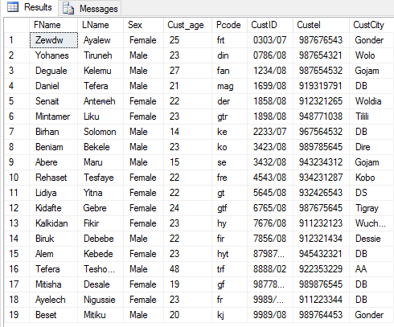

-- Employee in the Database

select * from Employee;

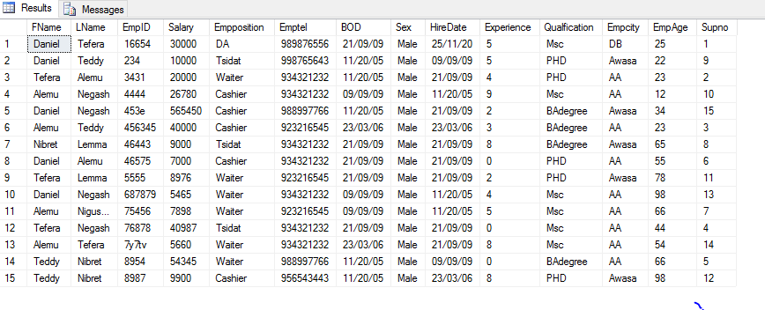

-- Order in the Database

select * from Orderr;

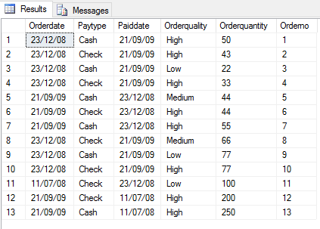

-- Supplier in the Database

select * from Supplier;

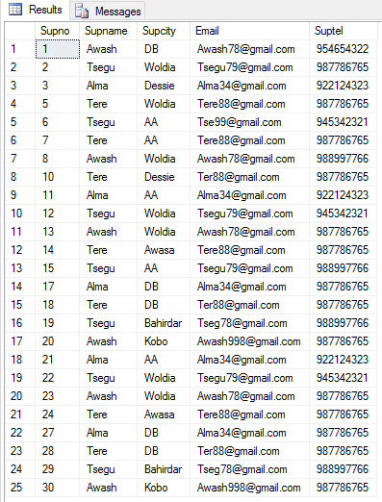

-- Food in the Database

select * from Food;

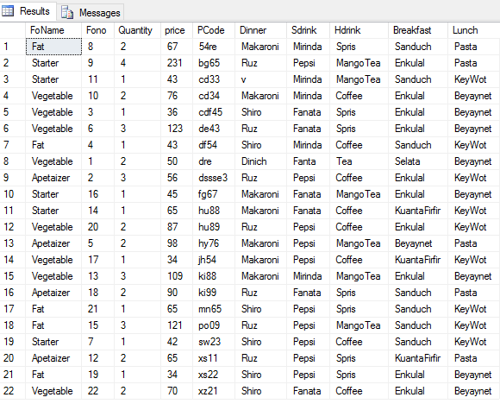

**Java Implementation**

We are also trying to do This database design implementation in Object Oriented programing (OOP) or java. Basically we are trying to do the implementation based on the database Entity, Attributes, Relationships.

Here simply we would like to show the log in page that when the manager wants to enter to the system it is asked to enter username and password unless and otherwise no one can enter to the system.

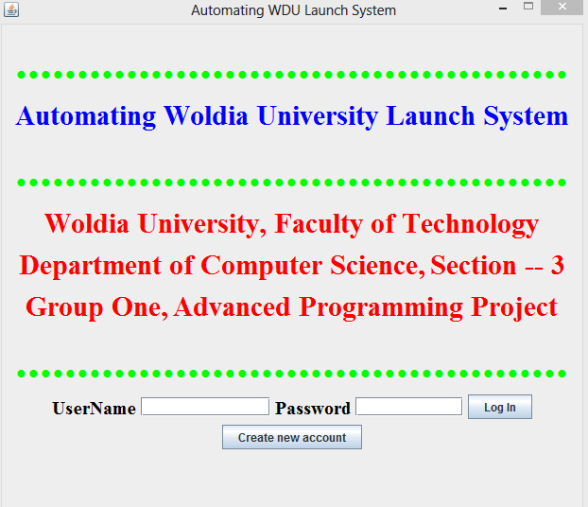

References

* Fundamentals of database management system Emissary third and fourth edition text book.
* Your exercise book
* Your fundamental and advanced data base hand out
* Webpage: Google

Thank you!!!